Contrast between HTTP/1.1 and HTTP/2.0

HTTP was founded in 1991 by Tim berners lee. It was considered as a official start of World Wide Web. HTTP evolved later on, as each new version was introduced it had new features. But, HTTP/1.1 was the first successful version released as it was the time web development was booming..

HTTPS/1.1
It was introduced in the year 1997.It is a text based protocol. It had the feature from previous HTTP 0.9 and additional to it it had new features like Keep-Alive, CORS.
Keep-alive enables the re-use of the same TCP connection for multiple request.
CORS(Cross origin resource sharing) is a mechanism which allows the to check for origin of the page other than from the own web browser(like packets, cookies etc)
HTTP/1.1 had lot of flaws as it did not have any feature which can be used for future purpose. It had only 1 TCP request which is too slow when compared to latest web sites as web pages are getting heavy.
HOL (head of line blocking) it was a issue in HTTP/1.1 as later the TCP request was increased to 6 TCP connection. Still that is less and if there are more than 6 request , 7th request has to wait till the connection time outs or it is rejected.
Repetition of Header Data is an issue , a header is sent along with every request which takes time and space . Some request doesn’t need a header.
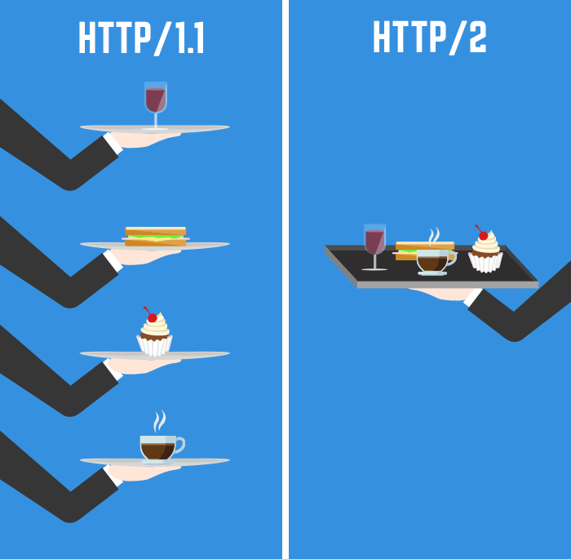

HTTP/2.0
It was released recently in 2015. It has single TCP connection with multiple streams inside the single pipeline and the request are sent through that pipeline. In simple words, the HTTP request are multiplexed into 1. And by the release of HTTPS the http/2.0 is much more secure and efficient.
The http/2.0 is built on top of HTTP/1.1, this makes the user who switches from HTTP/1.1 easier. HTTPS/2.0 is Binary Protocol so each byte is cleary defined
HTTP/2.0 has overcame the drawbacks faced in the previous release.
It has HPack, this seperates the header data from request data if enabled. This reduces the request size.
It has another good feature named “Push”. Push frame allows us to send mandatory resources in advance along with an HTTP response. This improves the speed and it must be handled with care as unnecessary use was lead to space and time problem

